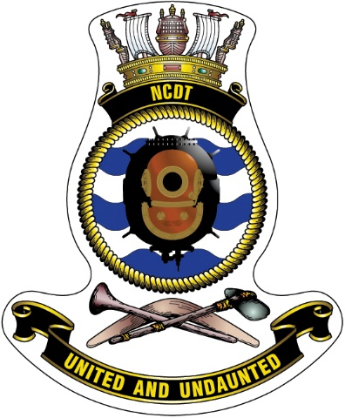

NCDT Scholarship Program

2023
Role of NCDT#2 The Navy Clearance Diver Trust No.2 (NCDT#2) is a charitable trust and has formed this scholarship program with the object of attracting funding to provide scholarships that will assist the highest risk group of transitioned clearance divers, those who have medically discharged, in gaining recognised training qualifications in their chosen area of civilian employment.

Purpose of Scholarship Program
The scholarship aims to provide support to transitioned CDs to take on new challenges through education and to upskill and develop qualifications that will support their new civilian lives

Candidate Assessment
The application will require the candidate to provide answers to address the following areas:
- Importance of training to achieve desired career outcomes
- Academic Potential
- Course or Training information
- Personal circumstance
For additional information regarding the program, please visit www.ncdt.org.au or follow this link

PERSONAL INFORMATION
- First Name
- Middle Initial
- Last Name
- Phone
- Email
- Address
- Date of Birth (DD/MM/YYYY)
- Gender
- Do you identify as Aboriginal or Torres Strait Islander?
- Marital Status
- Number of Dependents
- Next of Kin Details (Name & Contact)
MILITARY SERVICE INFORMATION
- Military Rank
- Service/PM Keys Number
- Number of Years in Service as a CD
- Reason for discharge
- What team, boat or unit did you discharge from?
- How would you describe your transition from the military?
COURSE / TRAINING NFORMATION
- What course/training are you interested in undertaking?
- What are your expected outcomes from this course/training?
- What is the cost of the course/training?
- Is the course/training a one-off or part of larger program?
- Have you undertaken this or similar training previously? If yes, what result did you achieve and how did you find the experience?
- Are you applying for / receiving funding from any other organisation for this or similar course/training?
TELL US MORE…
- What are your current career priorities and why?
- Are you willing to contribute to and support the NCDT during and post scholarship?
- Are you willing to participate in NCDT PR activities in relation to the assistance provided?
- Describe how you can best contribute to and promote the NCDT?
- In your own words, describe why this training/course is important to you and your family with consideration to your current circumstance and future endeavours (max 500 words / One page)
Q29: Start typing here

